1. Navigate to the document in the Public Documents library.
2. Right-click on the document and select *Copy shortcut*, *Copy link location*, or similar option provided by your web browser.  
   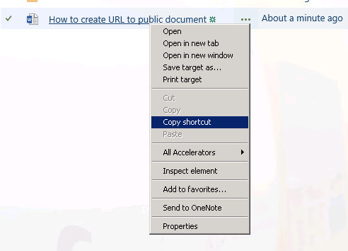
3. Paste the URL in your message.
4. Typically the link will be pointing to the web based viewer. If direct link to the file is needed remove "?Web=1" at the end of the URL.

Examples:

Link to this document, to be displayed in the web viewer:

<https://espace.cern.ch/amici/Public%20Documents/How%20to%20create%20URL%20to%20public%20document.docx?Web=1>

Link to download this document as a file:

<https://espace.cern.ch/amici/Public%20Documents/How%20to%20create%20URL%20to%20public%20document.docx>